Product description

Condensation hood for Salvis CucinaEVO 623T

Specification:

Type: | Condensation hood | 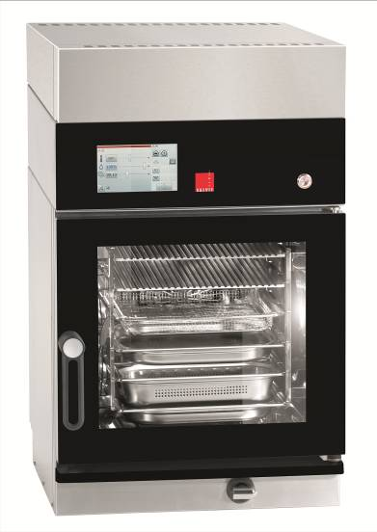
Dimensions (W x D x H): | 550 x 648 x 150
Connected load: | 0,06 kW
Voltage: | 230 V
Fan speeds | 4
Extraction capacity | 600 m³/h
Noise level | 48,5 dBA (2) – 58,0 dBA (4)
Protection: | Water jet protection IPx4
Max. energy consumption | 0,06 kW/h

Specific characteristics:

- Compact mounted unit for Salvis CucinaEVO 623T.
- Combination of hood and steam condenser.
- There is a minimal overlap from the outer contours to the Salvis CucinaEVO.
- Control and power supply via Salvis CucinaEVO.
- Fan level 1 switches on automatically when Salvis CucinaEVO starts
- Four-level blowing power is controlled automatically, dependent on the operating level of the Salvis CucinaEVO
- During cooking, steam and vapours condense and are removed by 4 heat exchangers
- Condensate drains directly through the drainage system of the Combi-Steamer
- Fan run-on controlled automatically by a timed relay
- Condensation effectiveness of hood system exceeds 80 %.

Execution / Specification:

- Housing and plate capacitors made of chrome-nickel steel AISI 304
- Surface smoothed
- Condensation hood with removable, dishwasher-safe grease filters

Subject to technical changes!
Manufacturer: Salvis AG, Nordstrasse 15, 4665 Oftringen, Switzerland

