QUOTATION TEXT
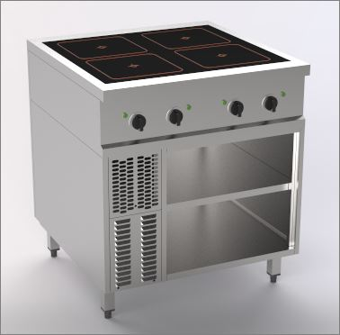 | Range Master Compact  Induction 4 zone round coils
 | Free standing unit
- Compact external dimensions
- Freestanding or wall-mounted installation
- Storage compartment accessible from the front
- operable from the front
- Even heat distribution
- Short heat-up time
- With energy-saving pan detection

Special features:

- Output 20 kW
- Low radiant heat
- 4 coils Ø 270mm
- Ceramic plate 720 x 650mm
- 4 height-adjustable stainlees steel feet from 894 - 930mm
- Incl. connection cable 1.5m

Design:
Induction hob with 6 mm thick ceramic plate and innovative large round coils,
ideal for à la carte cooking.ideal for the à la carte sector.
- Even the smallest pans can be used on the round coils.
- Flush-fitting, seamless glass ceramic hob with electronic pan detection to save energy.
energy saving.
- Simple and ergonomic knob operation.
- Electronic temperature control and pan detection.
- When the cooking equipment is placed on or removed, the heating power of the appliance switches on and off automatically.
- The infinitely variable setting guarantees sensitive control of the four separately adjustable cooking zones.
cooking zones.
- Large knobs, easy-to-understand symbols, scales and control elements on the ergonomically
control panel make work easier.
- The ceramic hob is glued flush into the cover, making it easy to clean and offering a high degree of hygiene.
- cleaning convenience and a high level of hygiene.
- Open substructure, accessible from the front, can be operated in Hygiene Standard with one
- adjustable shelf
- Cover in 2 + 2 mm, A-40 on all sides

Technical data

Outside L x D x H | 800 x 800 x 750/900mm
Glass size:  Coil size:  Number of heating zones  Storage space open:: | 720 x 650mm  Ø 270mm  4 Zones à 1 coil  540/598 x 759 x 468mm
Connected load | 400 V / 3~N / 20 kW / 3 x 32A
CE test and safety mark | CE
Device protection class | IPX4

Subject to technical changes!

