QUOTATION TEXT
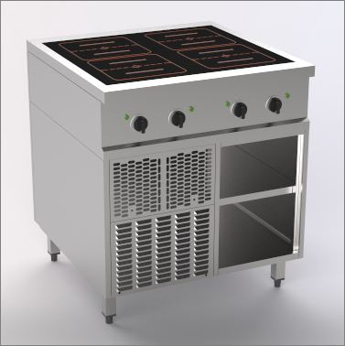 | Range Master Compact  Induction 4 zone full surface
 | Free standing unit
- Compact external dimensions
- Freestanding or wall-mounted installation
- Storage compartment accessible from the front
- operable from the front
- Even heat distribution
- Short heat-up time
- With energy-saving pan detection

Special features:
- Output 28 kW (2 x 14 kW)
- Low radiant heat
- 4 full-surface induction coils 260 x 135mm- Ceramic plate 720 x 650mm
- 4 height-adjustable stainlees steel feet from 894 - 930mm
- Incl. connection cable 1.5m

Ausführung:
- Induction hob with 6 mm thick ceramic plate and innovative large rectangular coils,
ideal for à la carte cooking.
- Even the smallest pans can be used on the round coils.
- Flush-fitting, seamless glass ceramic hob with electronic pan detection to save energy.
- Simple and ergonomic knob operation.
- Electronic temperature control and pan detection.
- When the cooking equipment is placed on or removed, the heating power of the appliance switches on and off automatically.
- The infinitely variable setting guarantees sensitive control of the four separately adjustable cooking zones.
- Large knobs, easy-to-understand symbols, scales and control elements on the ergonomically
control panel make work easier.
- The ceramic hob is glued flush into the cover, making it easy to clean and offering a high degree of hygiene.
- Open substructure, accessible from the front, can be operated in Hygiene Standard with one
- adjustable shelf
- Cover in 2 + 2 mm, A-40 on all sides

Technische Daten
Aussen B x T x H | 800 x 800 x 750/900mm
Glasgrösse:  Spulengrösse:  Anzahl Heizzonen  Abstellraum offen: | 720 x 650mm  160 x 135mm  4 Zonen à 2 Spulen  320/378 x 759 x 468mm
Anschlusswert | 400 V / 3~N / 28 kW (2 x 14 kW) / 2 x (3 x 20A)
Prüf- und Sicherheitszeichen | CE
Geräteschutzart | IPX4
Technische Änderungen vorbehalten!

