OFFER - SPECIFICATION
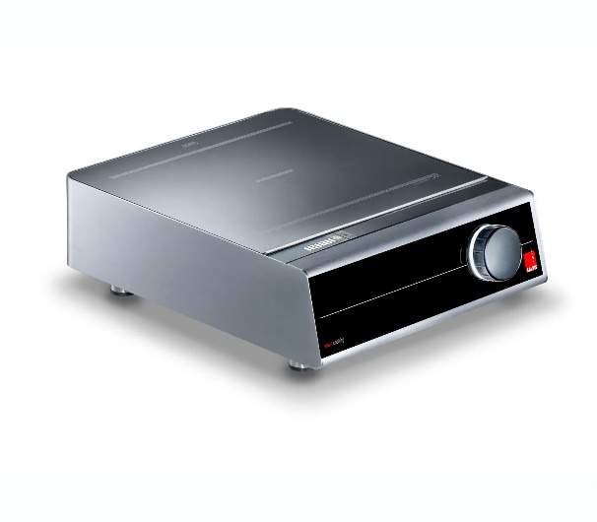
Induction cooking unit 1 zone (Salvis Compactline)
Powerful induction serving unit single version with one cooking point
- Short heating-up time
- High cooking performance
- Maximum comfort
- Easy handling

Specific characteristics

- State of the art induction technology with high cooking performance with 3500 W or 5000 W
- Short heating-up times, no pre-heating, rapid response to changes in power setting
- Compact dimensions

Construction / Specification

- Compact size: one case with flush mounted ceramic top
- The transmission of energy takes place by the coil and the power board below the ceramic top
- Simple operation via rotary knob with integrated power switch
- Electronic temperature control of induction coil, power board and logic print
- Microprocessor technology allows energy supply to be electronically controlled, monitored and optimised
- Ceramic top 372 x 349 x 6 mm with one cooking zone
- Due to an integrated pan detection, the cooking process is only possible with pan material suitable for induction

Documents
- Installation and operating manual

Technical data

Dimension Width  Depth  Height | 380 mm  460 mm  140 mm
Weight | 12 / 14 kg
Power | 3,5 / 5,0 kW
Voltage  Frequency | 230 V 1N / 400 V 3  50 / 60 Hz
Phase  Fuse | 1 Ph / 3 Ph  1x16 A / 3x10 A
Approvals | CE

Technical amendments reserved!

