OFFER - SPECIFICATION
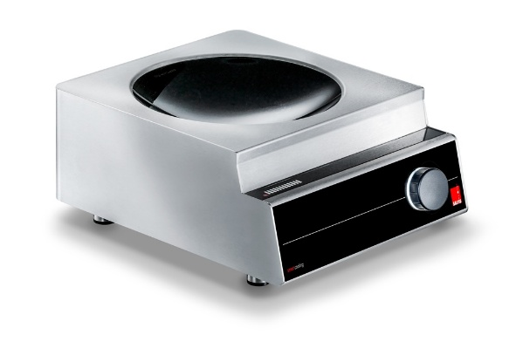
Induction Wok
Salvis Compactline
Induction tabletop unit with 1 flow-wok bowl
- Short heating-up times
- High cooking performance
- Maximum comfort
- Easy handling
Specific characteristics:

- Modern induction cooking unit for induction wok pans with 360 mm diameter
- High cooking performance with 3500 W or 5000 W
- Short heating-up times, no pre-heating, rapid response to changes in power setting
- Compact dimensions

Construction/Specification:

- Compact size: one case with recessed ceramic bowl with round coil arrangement for optimum efficiency
- The transmission of energy takes place via the coil and the power board below the ceramic top
- Simple operation via continuous power control
- Electronic temperature control of induction coil, power board and logic print
- Microprocessor technology allows energy supply to be electronically controlled, monitored and optimised
- Glass wok bowl for Wok pans with 360 mm diameter
- Cooking process is only possible with pan material suitable for induction
- Integrated pan detection
- Tabletop unit with 1 wok bowl

Documents:
- Installation and operating manual

Technical data

Dimensions: Width  Depth  Height | 380mm  473 mm  200 mm
Weight | 14 / 16 kg
Power | 3.5 / 5.0 kW
Voltage  Frequency | 230 V 1N / 400 V 3  50 / 60 Hz
Phase  Fuse | 1 Ph / 3 Ph  1x 16 A / 3x 10 A
Approvals | CE

Technical amendments reserved!

