OFFER - SPECIFICATION
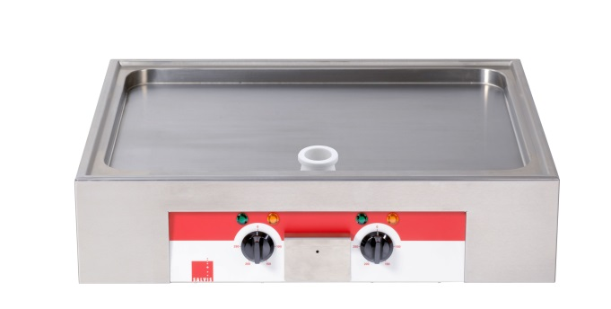
Griddle-plate double
Salvis Smartline 800
High performance grill appliance for best roasting results with minimum fat employment

- Individual
- Modular
- Versatile

Specific characteristics

- Flexible multipurpose apparatus to roast
- Temperature infinitely adjustable to 250 °C
- Griddleplate uncoated, rust-free, made of special stainless steel 1.2316
- Overheating protection and safety thermostat
- Even heat distribution

Construction / Specification

- Griddle surface smooth, deepened 704 x 506 mm
- Grease collecting drawer with integrated overflow the front of the Griddle surface
- Surfaces with rounded corners, joint less welds
- Appliance available as table-top model only
- with 1,5 m cable, without plug

Documents
- Installation and operating manual

Technical data

Dimensions:  Width  Depth  Height | 780 mm  615 mm  208 / 218 mm
Power  Voltage | 2 x 4,2 kW  400 V 3N AC
Frequency  Connection  Fuse | 50 / 60 Hz  3/PE  3 x 16 A
Approvals | CE
Protection | Water jet protection IPX4

Technical amendments reserved!

